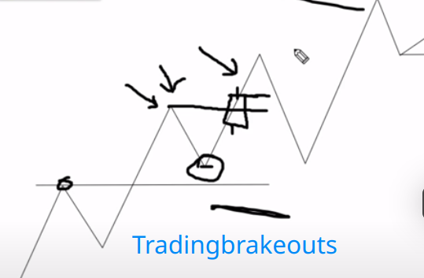Pullbacks.

There are three main pullbacks

1. Shallow pullback

2. The medium pullback

3. Deep pullback.

Shallow pullback.

Definition: A pullback that does not reach the previous resistance level before the market breaks into new highs.

Condition: we want to see a pullback that doesn't touch the previous resistance level for a bullish shallow pullback.

Trading shallow pullback.

The best way is by trading breakouts of this resistance level. After the pullback that didn’t touch the previous resistance level, the market pushes higher going into higher highs as we break out of this previous resistance level. Here is when i want to start looking for trades and i'm looking for those trades based on the close of the breakout candle.

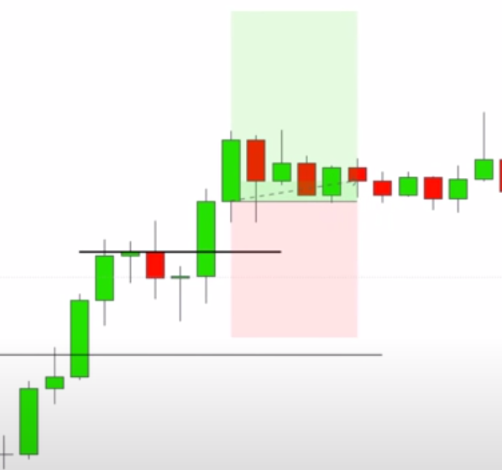

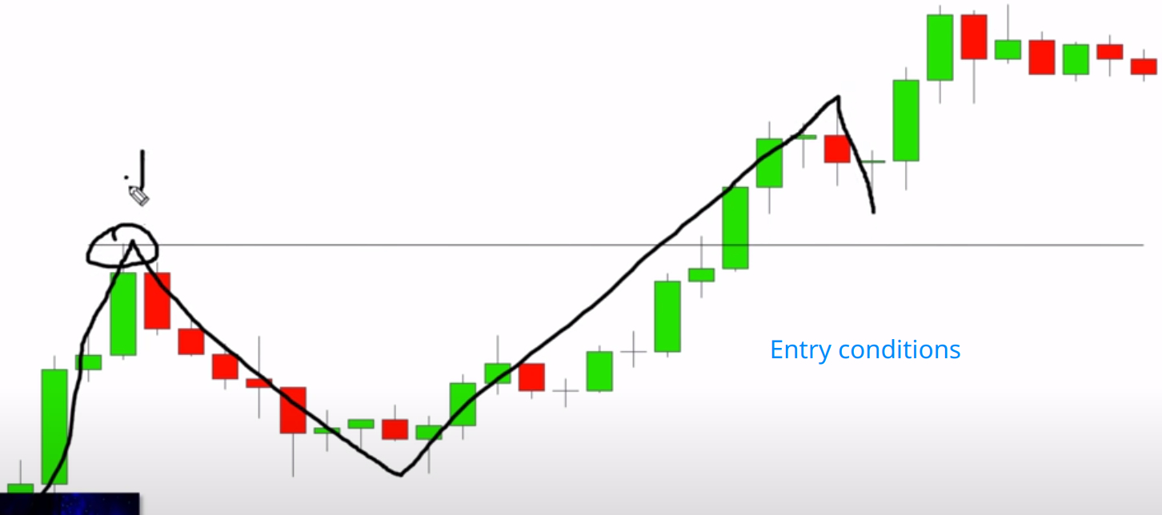

Breakout candle

Pullback

Trade setup

The medium pullback

A medium pullback is after we see the break and close

above a high, we see our impulsive move, and that pullback comes into the previous level of resistance.

Whenever a pullback makes it down to the level of previous resistance or support that was broken depending on the

trend this is an uptrend so it's going to be previous resistance turn to support this is going to be our medium pullback.

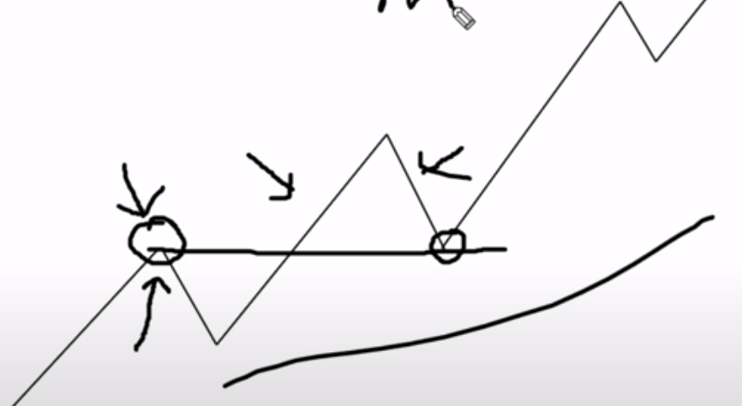

Deep pullback

When the market breaks into new highs from our previous resistance level and then the pullback makes it all the way down to the previous support level of the previous pullback.

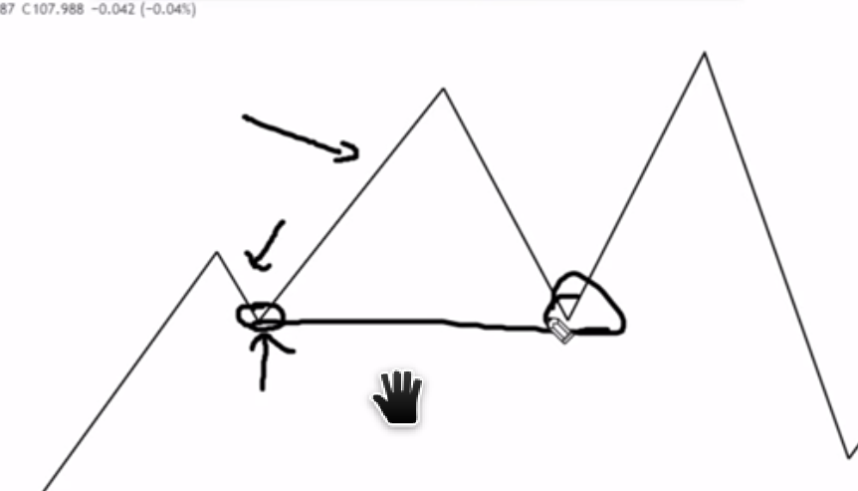

Entry Shallow pullback.

After we see that shallow pullback that does not touch the previous resistance level, is a close above the body of the previous resistance level the breakout candle that closed not the

high up here but the bodies of the candles of that

swing high when i get a break and close candle like this big green one here above this line our bodies of the previous wing high that is my entry candle so our trade setup at this point we would have a stop loss below the swing low and there's a couple of ways we're gonna talk about stops and targets we'll do that momentarily stop loss below the swing low.

NOTE: The breakout candle should have a full body (it can't be a doji or a pin bar).If the candle is full-bodied and closes below the support level, wait for yet another candle. This second confirmation candle should be smaller than the breakout candle and it should also close below the breakout level.

Entry

After we see that shallow pullback that does not touch the previous resistance level is a close above the body of the previous resistance level